ANNUAL REPORT 2015

“BUDDHA VIKLANG VIKAS SANSTHAN”

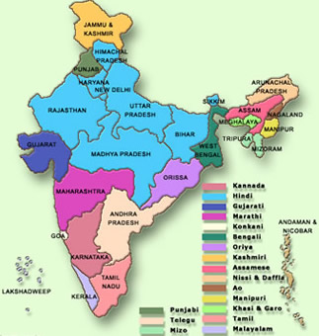
Regd Office
At. – BODH GAYA, DISTRICT- GAYA (BIHAR).

Dear Sir,
Chief Executive’s Message

There are fresh faces heading our government and we expect rapid growth in all areas, as the development sector continues to do its best for bringing about social change in India It is my pleasure to present the Annual Report of BUDDHA VIKLANG VIKAS SANSTHAN for the year 2012. As has been in the past, the year has been full of significant initiatives and approaches in the effort towards capacity building of NGOs and enhancing collaborations in the development sector. It has also given its best efforts to educate and develop- the people specially women, Children, SC/ST and Handicapped person through awareness programmer and formation of groups because most of the people of the project area of the society are uneducated and living below Poverty line as well as the condition of women is pathetic & dreadful.
I call upon our long-standing supporters to further strengthen BUDDHA VIKLANG VIKAS SANSTHAN so that we can keep the organization relevant and live to the development needs of communities. It is my especial pleasure to thank every member of this group and congratulate them for rising up to the new challenges. Wish you all the Readers and the whole team a very happy and prosperous future.

Secretary

NOTICE

ANNUAL REPORT
OF
“BUDDHA VIKLANG VIKAS SANSTHAN”
YEAR 2015
Your Executive Committee/Board of Trustee have pleasure in presenting the Annual Report of the Society along with Audited Statement of Accounts and Auditors’ Report thereon for the year ended 31st March, 2015.
- To receive, Consider and adopt the Balance Sheet as on 31st March 2015, the Receipt & Payment Account and Income & Expenditure Account, for the Year ended on that Date and the Reports of the Executive Committee and Auditors Thereon.

- To approve the constitution of the Executive Committee.

- To transact such further or other business may properly come before the meeting or any adjournment thereof.
Preface
Preface
Preface
Preface

“BUDDHA VIKLANG VIKAS SANSTHAN” is humanitarian focal Non-Government organization dedicated to develop the lowest rung of society on Socio-Economic Ladder, and having the ambition to improve quality of life of people by Rational Application of Oriental Yogic techniques, healthy life Styles and naturopathy and helping hand to the widows and children who are deprived of love & care, Books, and Teachers, food, shelter.

A Developed & Healthy Society, free of pains & sorrows, the very foundation of which is laid on the principles of
- legitimate rights
- Equality
- Justice
- Honesty
- Social Sensitivity
- And Self Reliance.

At present, our organisation is undertaking various activities at grass root level to give a new shape of the project area on all fronts-socio-economic and other social parameters.
In Short we have got the mission of Empowering the community and develop them by organizing different types of programmes like:
- Community health and family welfare programme
- Community Infrastructure Programme.
- Human Resource Development Programme, having thrust on skill development programme, to be conducted on wide network on through the scattered tiny NGO and Panchayat Raj representatives.
- Information interchanges network foundation.
- Provide immediate relief solution, to the people at grass-root.
- Perform Health Research and explain its benefits to the mass people

  - Empowering communities to attain the entitlements of socio-economic, cultural, and political spheres with enjoying civil rights.

  - To Research, Communicate, Identify and Wipe out the Country’s Socio-economic Challenges.

  - To conduct sound and feasible welfare and development programmes at remote, far-flung humanity, to join the mission to ensure India as developed nation.

  - To Co-operate and join hands with the funding agencies for the high impact of following welfare and development programmes of Government and general lawful activities.
  - To work for the eradication of illiteracy and provide quality education to all.

  - To prevent, detect, address and resolve health problems and implement cost effective and efficient health care delivery system.

  - To create awareness about the importance of environment and its preservation for good health.

  - To encourage and create awareness among local people preserving their cultural and traditional heritage.

  - To create better tomorrows for all in our Society.

Organizational Values & Beliefs
- Honesty
- Dedication to effectiveness and efficiency in service;
- A non-discriminatory and non-partisan approach
- Empathetic Dealings
- Transparency & Accountability
- Team work
- Respect for beneficiaries
- Responsibility to the next generation
Strategies
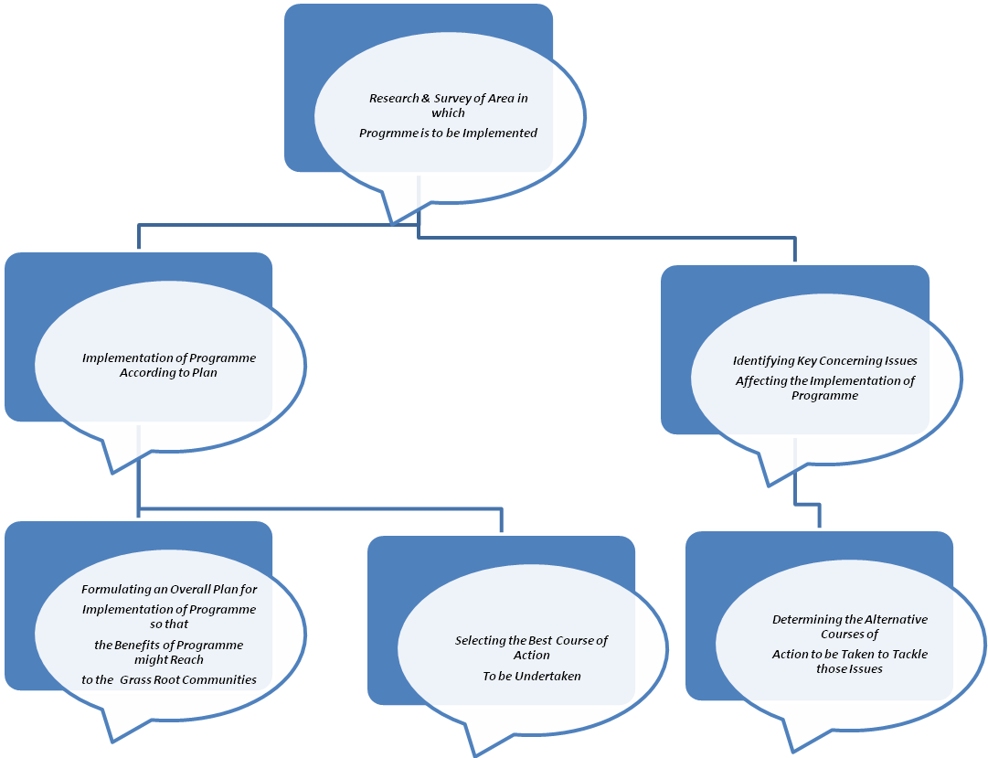

Methlogies
- Training
- Services
- Intervention
- Street plays
- Rallies
- Community meetings
- IEC development / distribution
- Mobile exhibition
- Health Camps
- Audio /Video shows
- Cultural programs
- Columns and articles in Newsletters
- Community mobilization

To,
The Member,
’’ BUDDHA VIKLANG VIKAS SANSTHAN”
Hon’ble Members
During the period under review the Financial, Physical Performance are as under:

P H Y S I C A L P E R F O R M A N C E

BUDDHA VIKLANG VIKAS SANSTHAN

ACTIVITY & PROGRAMME
SCHOOL FOR CHILD LABOUR:
Buddha Viklang Vikas Sansthan has been organizes child labour school at Bodh Gaya through donation in the financial year 2012-13. There were 200(Two Hundreds) child labour students have get education with lodging & fooding. Gaya District of Bihar State is most backward & Naxual effected area. The economic rate of this district is very poor. Due to Naxul area the vallager’s have not get benefit of Government’s scheme. Our society has select 200 child labours for education from local villagers.
All child labour’s students have get education with residential facility . Time to time the doctor has visit in school for checkup of student’s health. The dress, bedding & blankets facilities are available here in the education period. The education course is like bridge course.

VOCATIONAL TRAINING FOR HANDICAPPED CHILDREN:
Our non-Governmental organization has been organized Residential Vocational Training Programme for disabled person. Through the advertisement with village wise, we have chose 165 (One Hundred Sixty Five) handicapped youths for vocational training,. Due to unemployment the handicapped youths have depended on their family. They have good infrastructure in the training period. The handicapped youths have like the income generation training prorgramme for their livelihood. After the training, they are able to employment.
The training management committee of our organization has been reported handicapped in the district, the matter was discussed in the managing committee meeting. The matter was resolved positively to open and run to provided facilities to handicapped.
The local expert persons were called for the said residential training. The programme was successfully. It was decided to roganise much more programme on account of vocational training frequent enquiries are being received from the next vocational training programme.

HELP TO HANDICAPPED PERSON.- REHABILITATION OF DISABLED PEOPLE:

SURVEY:
Survey on handicapped socio economic and employment/education status of the disabled people of the block and district was conducted by this organization. It was done for the purpose implement development education , rehabilitation and welfare for development of handicapped populace, seventeen Blacks of the Gaya District were covered.
The base line survey with exhaustive questionnaire was conducted for handicapped development rehabilitation among the various disabled of Gaya District.
ORIENTATION PROGRAMME:
Our society has been organize basic orientation training programme for development of handicapped person at different place of Gaya District.
MEDICAL CAMP:
Our society has been organize Medical Checkup Camp in Bodh Gaya for health development of handicapped persons . we have distributed medicine for genuine person.
DISTRIBUTION OF DISABLITY AIDS:
Buddha Viklang Vikas Sansthan has been organized distribution of disability aids programme under rehabilitation programme for disabled people in Bodh Gaya. The details are given below:-

Secretary

OTHER ACTIVITIES
Organization executed many other programmes and people got benefited in large scale. Some information has also been recorded from different localities for future use.

AUDITORS
S.K DUBEY & CO. Chartered Accountants, GAYA have conducted the audit for the year and are re-eligible to be re-appointed for next year.
The managing committee places on paper and its sincere thanks to the workers, members and beneficiaries for extension of co-operation and efforts. For and on behalf of

’’ BUDDHA VIKLANG VIKAS SANSTHAN”S

(Secretary)

